THEORY QUESTIONS
1.
(a)

Study the worksheet below carefully and use it to answer (i - vi)
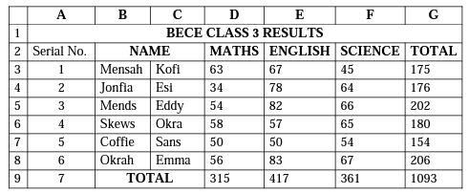
(i)

Outline the step s by which the Serial No. (1, 2, ... ,7) were generated without typing them one by one.
(ii)

What is the cell address in which the name "MATHS" was entered?
(iii)

Write down the cell range in which "BECE CLASS 3 RESULTS" was typed.
(iv)

Write the spreadsheet formula that was used in computing the total value "202" in cell G5.
(v)

Write the spreadsheet function used in computing the total "417" in cell E9.
(vi)

How many cells are in the cell range C3:E6?
(b)

Outline the proper way of shutting down a computer after using it.
(c)

Identify the following web browsers:
(i)


(ii)


(ii)



2.
(a)

State three uses of the shift key on the computer keyboard.
(b)

Write down the acronyms below in full:
(i)

HDD;
(ii)

VDU;
(iii)

BIOS.

3.
(a)

State two functions:
(i)

of an input device;
(ii)

performed by an output device.
(b)

Match items in Group 1 to those in Group 2 with lines
Group 1 | Group 2
Speedometer  Electric Stove  Money Counting Machine  X-ray Machine | Bank  School  Hospital  Vehicle  Home

4.
(a)

State three ways through which computers may be damaged.
(b)

List three specific areas of learning where ICT tools can be integrated.
(c)

List three devices that may be used for transmission of messages on the internet.

5.
(a)

The Operating System makes it easy to store files in places that make a lot of sense. Give the default folder or storage area for the following files:
(i)

Text files;
(ii)

Image files;
(ii)

Music files.
(b)

Write the shortcut keyboard keys combination for the following commands as used in a word processing environment:
(i)

Undo;
(ii)

Find;
(iii)

Select All.
(c)

List three toolbars available in a word processing application.

